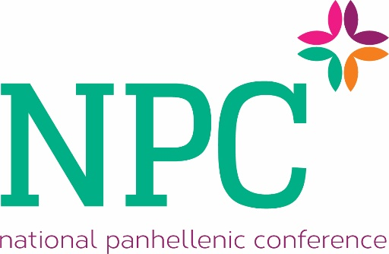

Sample Extension Presentation Evaluation

Name:
Chapter affiliation:
Presenting organization:

Please evaluate the sorority on the following criteria--write any necessary comments for each criteria.

Inter/national headquarters support
Poor Excellent
1 2 3 4 5 6
Comments:

Chapter and alumnae support
Poor Excellent
1 2 3 4 5 6
Comments:

Member development program
Poor Excellent
1 2 3 4 5 6
Comments:

Strength of colony development plan/past colonization successes
Poor Excellent
1 2 3 4 5 6
Comments:

Overall rating
Poor Excellent
1 2 3 4 5 6
Comments:

General comments regarding this organization:

Extension Evaluation Criteria
Please review the following criteria before you rate the sororities.

Affiliating (use if a local organizations is seeking NPC affiliation)
- Are they willing to affiliate the active members of the local organization?
- Do they seem enthusiastic? Are they reluctant?
- Have they exhibited a plan for integrating these women into the NPC sorority?
- What are the strengths and weaknesses of this plan?
- Do they have past experience absorbing an interest group during colonization?
Notes:

Ability to hold a large capital campaign (use if housing is needed)
- Does the organization have a strong Foundation base or endowment?
- Are there alumnae in the area?
- Do they have prior experience holding capital campaigns?
- Is their fundraising plan viable?
- Is there evidence of sufficient fundraising staff to hold such a campaign?
Notes:

Support from headquarters
- Does the organization provide prolonged staff support or several brief visits over time?
- Does the organization provide strong volunteer support to their colonies?
- What kind of support does the organization provide its alumnae advisors?
- What are the strengths in this area?
- What are the limitations in this area?
Notes:

Support from surrounding chapters and alumnae
- Where are the closest chapters?
- How old are the chapters that are close?
- Is there a prescribed way these chapters might interact with the colony?
- Is there a sizable alumnae base in the area?
- Has the organization already identified alumnae that are interested in working with the colony on campus?
- What are the strengths in this area?
- What are the limitations in this area?
Notes:

Strength of the member development program
- How does the organization educate new members who come into the group? Is it a traditional new member/big sister system? A total membership education program that involves all members? Something else?
- Do you feel that the organization’s member development program will add something to the lives of those who participate? How?
- Do you feel that the member development program makes use of institutional resources, alumnae, other areas of assistance for the colony/chapter? How?
- What are the strengths in this area?
- What are the limitations in this area?
Notes:

Strength of colony development program
- Does the organization provide a detailed process the interest group will go through to become a colony?
- Does the organization provide a detailed process the colony will go through to become a chapter?
- Do you feel that the process is reasonable and achievable? Why or why not?
- What are the strengths in this area?
- What are the limitations in this area?
Notes:

General comments
This is a section where you might want to think about the following questions:
- How does this organization compare with others?
- Do you see a fit between our fraternity/sorority community and this organization?
- What does this organization bring to our fraternity/sorority community that is not currently present?
- What limitations does this organization have?

